Academic Appeals Policy
Introduction
CECOS College London academic appeals procedure is informed by the Office of the Independent Adjudicator (OIA) and QAA UK Quality Code for Higher Education Theme: Concerns, Complaints and Appeals. This procedure applies to qualifications accredited by ATHE, Pearson City and Guilds, OTHM, NCFE, TQUK and other awarding bodies as appropriate. The Appeals Policy applies to all levels of qualifications including Entry to level 3 provision accredited to the Regulated Qualifications Framework (RQF) as well as levels 4 – 7 in the RQF and in the associated levels in the Framework for Higher Education Qualifications (FHEQ). The policies of partner organisations may also apply, and students have the right to appeal to the validating university in the case of degree provision and to the awarding bodies, but only once all College appeals procedures have been followed.
Purpose and Scope
The purpose of this procedure is to allow CECOS College London students/learners the opportunity to raise concerns about their assessment results and the outcomes of Boards which make decisions on progression and awards. Such concerns are taken very seriously by the College and its awarding bodies and organisations. The procedure is designed to enable a student’s concerns to be considered fully and addressed in a timely and appropriate manner. The academic appeals procedure will be published on the College website and communicated to all students/learners as part of their induction process.
Robust mechanisms exist at CECOS to ensure that assessment is fair and appropriate. Assessment is conducted in accordance with the awarding body regulations and requirements. Assessments, as appropriate, are subject to internal verification and samples are checked by External Examiners (EEs), External Verifiers (EVs) and External Quality Assurance (EQA) representatives of the awarding bodies who oversee the assessment process. The academic appeals procedure may be instigated if a student/leaner wishes to make an appeal against an assessment decision based upon their academic achievement, or based on objections to the decision-making process including bias.
All assessment results remain provisional until they have been reviewed by EQAs/EEs/EVs. Students also have the right to appeal to the awarding body once results have been finalised. However, appeals to awarding bodies, partner institutions or the OIA can only be made once the internal College appeals process has been completed.
The College also has the right to appeal to the awarding body or institution on behalf of its students if it identifies evidence that the decision-making process of the external scrutiny has been unfair or mismanaged.
Definition
CECOS applies the definition of an appeal as that provided in the UK Quality Code as: ‘a request for a review of a decision of an academic body around a mark, outcome or decision. Students may appeal an outcome on the basis of evidence or procedure, but not on the basis of disagreement with academic judgement’.
An academic appeal differs from a complaint and therefore appeals and complaints are considered under different policies and procedures.

The Right of Appeal
Any student who submits an appeal under this procedure will not be disadvantaged for having done so. Appeals will be handled with sensitivity with due regard to the confidentiality of all parties. Details will only be shared with staff who need to know in order to investigate and respond. The Appeal will be investigated by the exams officer. Where an Appeal relates to a decision of the Assessment Board, the reconvened Assessment Board will include a member of curriculum staff independent from the programme area concerned.
Grounds for academic appeal may include:
1. Procedural irregularities in the assessment process or decision-making linked to grading;
2. Extenuating circumstances that could not be made known to the Assessment Board.

Grounds for academic appeal are not normally considered in relation to academic judgement or decisions made on the quality of work. The form for lodging an appeal is available to students on request from Reception.
3. Other matters of dispute shall be termed "complaint” and are subject to the College Complaints
Procedure.

In the event of justifiable grounds for both appeal and complaint, the Programme Manager will confirm the method by which both the appeal and complaint shall be resolved. This shall be determined in consultation with the appellant/complainant. In the case of handling both complaint and appeal it may be that one procedure is suspended, pending the completion of the other.
The Appeals Procedure.
The procedure includes both formal and informal stages.
- The Informal Stage
The informal resolution stage seeks to resolve straightforward concerns swiftly. At any meeting the student has the right to appoint a representative to take them in the meeting with them.
If the appeal relates to a grade you have received, please contact the exams officer within 5 working days of receipt of the results and raise your concerns by emailing exams@cecos.ac.uk.
The outcome of the informal stage will be given in 10 working days following the appeal and should be one of the following:
- The student is content with the decision
- Proceed to formal stage.

- The Formal Stage
The stages of the formal appeals process are set out in the table below.
Nature of the appeal | Form to be completed | Managed by | Reason for appeal
Formal Stage 1 (Appeal form to be submitted within 5 working days of the outcome of Informal stage) | College appeals  form available  from reception | Programme Manager | Procedural irregularity,  perception of bias,  extenuating circumstances  which could not be made  known.
Formal Stage 2  (To be submitted within 5 working days of the outcome of the Formal stage 1) | Completed Appeals Form submitted | Academic Review  Panel | Student not satisfied with Stage 1 outcome.
External Appeal  (To be submitted within 5 working days of the outcome of the Formal stage 2.  Students may appeal to the awarding body or partner university if they feel that the outcome of the College Appeals Process has been unfair or has failed to address their concerns. | College’s appeal  procedure has  been exhausted.  Form or letter to the awarding body (as set out in the appropriate awarding body appeals policy) | Awarding Body or partner university | Dissatisfaction with the  outcome of the College’s  appeals procedure.  Any appeal must be made within ten working days of the formal stage outcome letter date.  The appeal will consider whether the College properly used procedures that are consistent with awarding body or organisation requirements in reaching judgments.
Appeal to the Office of  the Independent  Adjudicator (OIA) | Letter to the OIA | OIA | Dissatisfaction with the outcome of the College Appeals procedure and/or awarding body procedure.

Further information and Appeals Procedure timelines
At each stage of an appeal students/learners will be advised of the next stage of appeal or review. Once all appeals procedures have been exhausted, the College will issue a Completion of Procedures letter. This should be provided within 21 working days.
Academic Appeals will consider at each stage whether:
- the original decision was procedurally correct;
- the original decision was taken on the basis of the correct information;
- there is new, additional information to be considered;
- there are valid reasons for this information not being presented previously;
- the appellant has been treated fairly.
Once the appeal stage has been completed, including any appeal to the relevant awarding body, students/learners are entitled to ask the Office of the Independent Adjudicator (OIA), the independent ombudsman service of last resort, to look at their appeal. All applications to the OIA must be made within twelve months of the date of the Completion of Procedures letter issued by the College to the student.
The OIA considers complaints about the outcome of the College’s appeals process from people who remain dissatisfied at the conclusion of the College’s appeals procedure. The OIA looks at issues such as:
- whether the College followed its procedures;
- whether these procedures were reasonable,
- whether the College’s final decision was reasonable in all the circumstances.
The College will respond to any OIA enquiries in line with OIA timeframes.
The OIA cannot normally look at appeals:
- where the student has not progressed through all stages of the College’s appeals procedures;
- where the appeal refers to matters more than three years old;
- where the Completion of Procedures letter is received outside the twelve-month time period.
Annual review and publication of academic appeals
The academic appeal procedure is approved and reviewed annually by the Quality Management Group. As part of this review a report on appeals is considered. The aim of this is to ensure the academic appeal procedure continues to meet developments in the HE and FE environment and positively contributes to and complements other quality assurance systems informing, where relevant, any improvements required to enhance the student experience.
Student representatives are invited to attend the annual review and contribute to any decision making in relation to changes to the procedure.
Anonymised appeals summary reports will be considered by the Academic Board and made available to Governors and to the awarding bodies, organisation or other external agencies as required.
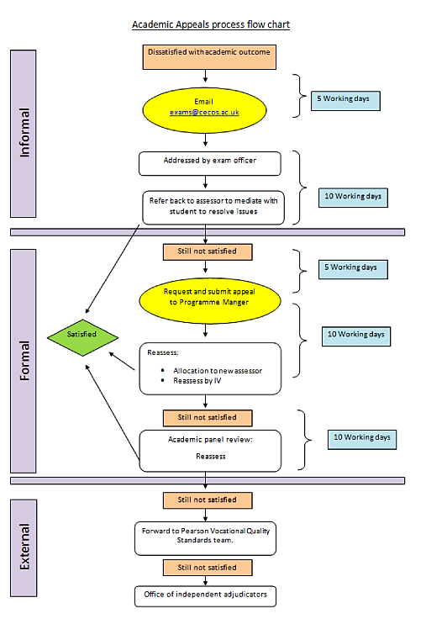
Forward to awarding body under their appeals procedure

