**STUDENT ADMISSIONS POLICY**

*Additional procedures may be issued if an identified need for further guidance or clarity emerges.*

**Policy Statement**

This policy and procedure is subject to The Equality Act 2010 which recognises the following categories of individual as Protected Characteristics: Age, Gender Reassignment, Marriage and Civil Partnership, Pregnancy and Maternity, Race, Religion and Belief, Sex (gender), Sexual orientation, Disability.

CECOS operates a centralised admissions process ensuring a common and transparent approach for all applicants should they apply online through the website or through hard copy paper application. The College’s Admissions Policy sets out the means by which we will encourage and welcome applicants with different educational and social backgrounds.

As per section 1.14 of the Competition and Markets Authority guidance for HE providers, we will ensure that applicants are provided with the information they require to make an informed choice. The College is committed to ensuring that all applications are considered and evaluated on the basis of individual potential.

**Introduction**

CECOS College London regards the operation of an effective student/learner admissions process as vital to the success of the College. The College seeks to comply with the guidance and requirements of set out Supporting Professionalism in Admissions (SPA) and the Principles of Fair Admissions set out in Swartz Report (2004) and to provide guidance to students, staff and collaborative partners. CECOS College will also comply with the requirements of its partner university and colleges in the recruitment and admission of students, as well as criteria appropriate to funding bodies.

**Terminology**

In the context of this policy, ‘admissions’ is taken to include all arrangements whereby students are informed about the College, apply for its programmes, are selected for enrolment and are introduced to the requirements of their chosen programmes.

Widening access refers to the process by which the College may vary their selection and admissions processes according to local or national policy guidelines and expectations. The College seeks to operate an inclusive admission policy which seeks to minimise unnecessary barrier which may prevent any students from making a successful application.

**Scope**

This policy covers arrangements by which students are initially informed about the College and enabled to select appropriate programmes, together with applications for enrolment, diagnostic testing, selection, enrolment and the induction of new students to the College.

***UK Quality Code reference themes***

Admission, Recruitment and Widening Access

Enabling Student Achievement

Partnerships

Work-based Learning

**Related procedures**

Enrolment and selection procedures

Diagnostic testing procedures

English language testing and support

Recognition of Prior Learning (RPL) policy

Induction Policy

**Principles**

Your application will be treated courteously, fairly and without prejudice and we will act in accordance with the College’s Equality and Diversity Policy.

We will review our entry requirements, admissions procedures and practices regularly, including simplifying the applications process. We will provide clear and objective pre-entry guidance on our website on all matters relating to admissions.

**Minimum Expectations**

CECOS is committed to ensuring that its Admissions process is fair for all. To achieve this, we ensure that all staff are adequately trained and undergo a full induction period. In return, it is expected that students demonstrate appropriate behaviour and attitude.

The College expects applicants to provide accurate information on which to make Admissions decisions. Any student found to have provided false information or to have plagiarised their personal statement are at risk of having an offer withdrawn or being asked to leave the programme.

**Aims**

The overall aim of the policy is to ensure that the College operates a clear, fair and consistent set of arrangements to select and admit students and to introduce them to their programmes of study in line with the *Guiding Principles* of the Quality Code Advice and Guidance on Admission, Recruitment and Widening Access. This will include ensuring that all processes that:

* Are transparent *(Guiding Principle 1)* including the **entry requirements** of each course and **English Language proficiency levels[1]**
* Enable the selection of students who are able to complete the course, as judged by their achievements and their potential *(Guiding Principle 2)*
* Utilise assessment methods that are reliable and valid *(Guiding Principle 5)*
* Seek to minimise barriers for applicants *(Guiding Principle 3 & 6)*
* Are professional in every aspect and underpinned by appropriate institutional structures and processes. (5 Principles of Fair Admissions, Schwartz 2004)

**Objectives**

The objectives of the Admissions Policy and its related procedures are:

* to ensure that all promotional materials used to inform prospective students about the College are accurate, complete and fit for purpose;
* to ensure that any student recruitment activities on a face-to-face basis which are commissioned or directly organised by the College are managed efficiently and professionally and that prospective student enquirers are dealt with in a courteous and supportive manner;
* if and when recruitment agents are used in the process of student recruitment, to ensure that they operate to the expected and published standards of the College and that their activities are regularly monitored;
* to ensure that information for prospective students includes appropriate and accurate guidance about welfare and pastoral services, as well as specific material to assist students from outside the UK and those who are returning to learning;
* to ensure that selection criteria are fair, reasonable and clearly stated and that all staff dealing with student recruitment and admission work with prospective students in a supportive and friendly manner;
* to make arrangements for the efficient and confidential recording of all decisions concerning selection and to ensure that all communications with prospective students are conducted in a supportive and non-bureaucratic manner;
* to manage diagnostic testing where required, with efficiency and sensitivity including testing for English Language proficiency at the required level for the chosen course and key skills;
* to ensure that successful applicants are fully informed about the College`s enrolment requirements including where appropriate the need to comply awarding body and with partners institution requirements, as appropriate;
* to ensure that applicants who have not been offered a place are informed in a sensitive and supportive manner;
* to ensure that all complaints and appeals about the student admission process are dealt with in an efficient, fair and reasonable manner;
* to ensure that induction of new students is provided in a timely, supportive and informative manner;
* to review on a regular basis the operation, currency and fitness for purpose of all procedures relating to student admissions.

**English Language Proficiency**

All applicants must provide evidence of their English Language Skills. For applicants who have undertaken education in the United Kingdom (UK) this may include a GCSE in English, copies of previous qualifications obtained in the UK, or a transcript of credits achieved.

Where students do not have the required evidence to meet the English Language entry requirements, they will be offered a College test, and skills will also be further assessed through interview.

**Induction**

All students once offered a place on their chosen course will undergo an induction to the College. The induction process covers information on essential College policies and procedures, information on attendance requirements, a session on the dangers of radicalisation and extremism, academic malpractice and the student code of conduct. Attendance at induction is a mandatory requirement for all students, and late induction sessions are organised for those students unable to attend induction in the first week.

An introduction to the course of study is also provided, and course handbooks including information about assessment requirements are available through the virtual learning environment, Moodle.

**Transfer between Courses**

Student may be able to transfer between courses, particularly in the first 2 -3 weeks of the start of their course, provided that they meet the requirements of the course they would like to transfer to, and that there are places available. Where students wish to transfer to another course and carry credit over, this will need to be mapped against learning outcomes, and the approval of the awarding body, and/or partner institution, as set out in the Recognition of Prior Learning Policy.

**Course cancellation or change**

CECOS remains determined to deliver all courses advertised in promotional material. The College however retains the right in certain circumstances to change/discontinue a course as a result of circumstances beyond its control/reasonable foresight. In instances where course changes/discontinuance is unavoidable, the college will use all resources at its disposal to ensure applicants and affected students are offered an alternative solution with other local providers.

**Data Protection**

CECOS demonstrates its commitment to adhering to the General Data Protection Regulations and the Data Protection Act (2018). This ensures that information about all applicants (without discrimination) is treated as personal and sensitive data and stored securely to maintain confidentiality. Further, the College ensures that that data collected from applicants is only collated to facilitate analysis, trends and monitoring including as required by external authorities and awarding bodies.

**Responsibilities**

The Managing Director (MD) and the Principal along with senior admission staff are responsible for monitoring the implementation of the admissions procedure for all students. Programme Managers will ensure that any required diagnostic testing is undertaken in a timely manner. Student Services staff under the direction of the Principal and the CEO will ensure that all admissions comply with fair and transparent procedures in line with the those set out by the Regulatory and Funding Authorities and those included in the Quality Code for Higher Education.

**Admissions Stages**

The diagram below sets out the key stages in the Admissions process, to ensure that all applications are treated in a consistent, transparent and fair manner. Where students do not feel that they have been given fair consideration, they have the right to Appeal. Where this occurs, the application documentation will be reviewed by a senior manager who has not been directly involved in the

**Admissions process or decisions**

In most cases admission decisions are made by the Director of Operations and the Head of Programme within whose area the programme the applicant has applied for sits. The Director of Quality or an independent Head of Programme may be asked to consider decisions of a difficult or sensitive nature.

Where an appeal against an admission decision is made, the decision of the independent Reviewer and any recommendations will be considered final.

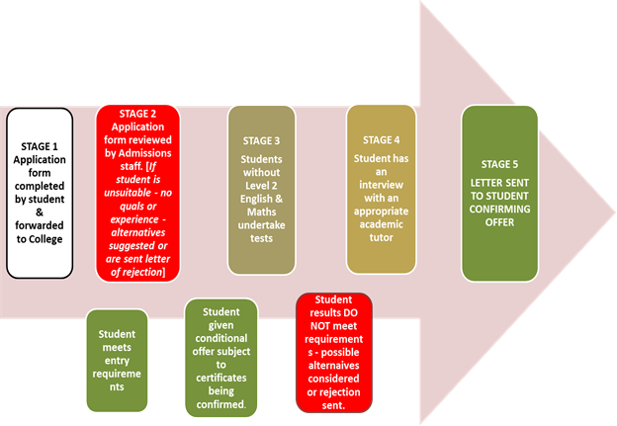

If programme is not suitable for meeting student needs – alternatives suggested

**Procedures for the applicants who are returning to education**

CECOS encourages individuals from a wide range of experiences to apply to study at the College. The applications from all applicants are considered against the standard entry criteria of the course that they are interested in. They are also required to provide evidence of their working experience that can be used as alternative proof of meeting the entry requirements for the course. This approach meets the Accreditation of Prior Learning or Recognition of Prior Learning (RPL) principles.

**Post admissions procedures:**

All selected prospective students are required to attend an induction programme, for which the student attendance is mandatory, and all the individuals are notified of the programme well in advance. During the induction, the students will be provided with the student handbook, which they can use as a guide while they are studying.

The prospective student’s queries can be addressed during the induction, and useful information will be provided then. The prospective students are required to complete enrolment information which will be collected and processed by the administration department.

The enrolment forms, the student files and all relevant documents will be scrutinised further and once it is established that the file is complete by meeting all the conditions in the conditional offer letter, the students will be issued with identity cards and are enrolled for the course sessions.

The timetables for the respective scheduled classes will be confirmed and course details discussed with course team staff during the induction. Students attending their course may be expected to attend additional workshops to support the different stages of their course, in addition to their main course of study, and this will be clearly indicated.

Admissions to CECOS are managed by the Admissions Department to ensure consistency of practice, knowledge and experience.

The Admissions Policy and Procedure is available on the website and is reviewed formally annually and more regularly when new regulatory requirements are published. The Policy gives a comprehensive description of CECOS’s approach to equality and diversity throughout the admission process and sets out the roles and responsibilities within the service and academic departments.

All staff involved in the administration of admissions and those involved in selecting and interviewing applicants, undertake regular training to ensure continued professional competence is maintained. Training includes attendance at compulsory College sessions, e.g. Equality and Diversity, Disability Awareness, Health & Safety and Regulation & Governance. All admissions and academic staff involved in admissions work are required to complete CECOS’s compulsory sessions on an annual basis.

**Applicants with Disabilities**

The College is committed to achieving equal opportunities for all students and actively encourages potential students who may be disabled or who may have an additional need to make an application.

Prospective students with disabilities are encouraged to visit the College, to view the facilities and assess their particular requirements. Students interested in applying are encouraged to contact the College for information about facilities. The College seeks to ensure that disabled students meet their full academic potential and are not discriminated against either during the admissions process or in their subsequent time as a student.

There is a range of disabilities and short or long-term conditions that can impact on students’ academic work. College specialist advisors may assist students in a variety of ways to ensure that they can continue to study, are supported in the most effective ways, and receive any grants to which they are entitled. Students can talk to the team in confidence about any concerns about their learning support needs and they will receive advice on how to obtain the support needed.

If students have a disability or long-term medical condition (including mental health concerns) which is likely to affect their studies they are encouraged to declare it at enrolment or as soon as they become aware of it. Students can contact their programme leader or course co-ordinator, or approach the Student Services Team. Once notified, they will put in place a process to review the individual student’s needs and make any necessary adjustments to their studies.

Whilst every effort is made to accommodate an individual’s needs for support, in exceptional circumstances it may not be possible to make reasonable adjustments to enable a student to access their chosen course. Where appropriate, students will be directed to other colleges or universities who may be better able to accommodate their needs.

The College’s policy is to assess all applications on the same academic grounds and to try to provide additional services and facilities where appropriate.

**Minimising Barriers**

CECOS aims to minimise any barriers that are irrelevant to Admissions requirements. These could potentially come from:

* Means of assessment;
* Resources and support available to applicants;
* Disability;
* The type of applicant’s qualification.

**Feedback and Complaints**

Any applicant who is not satisfied with the way in which the College has dealt with their application may complain using the College website or visiting the reception area at each Campus.

The College’s complaints procedure applies to both HE and FE students, as well as the general public. In addition, all higher education students who receive student support funding, have access to the same dispute resolution arrangements as any other student on a higher education programme in England. The Office of Independent Adjudicator’s (OIA) is the Government’s designated operator for handling unresolved student complaints in higher education, it provides an independent, transparent complaint handling scheme to review student complaints and academic appeals.

More information about the OIA can be found on its website [www.oiahe.org.uk](http://www.oiahe.org.uk)

In cases where courses are partner with other organisations, all students are welcome to raise any concerns with the partner institutions directly.

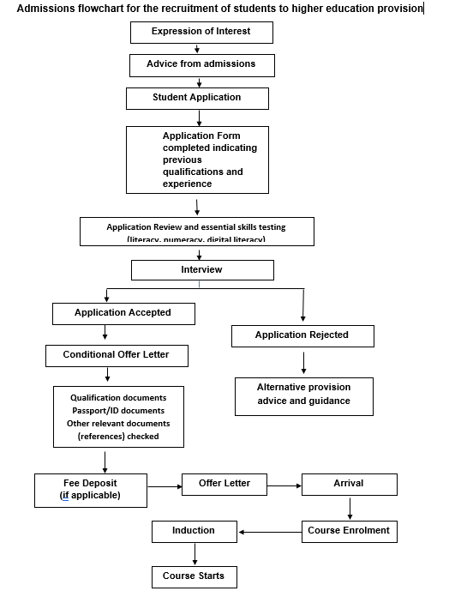

1. All course information published on the website includes information on entry requirements and the level English Language proficiency (generally IELTS 5 – 5.5 or equivalent).