Reasonable Adjustments and Special Consideration
Introduction
This policy is aimed at staff and students/learners, who are delivering/enrolled on or have taken an approved qualification or unit. The term ‘reasonable adjustment’ refers to students/learners who, by reason of disability or impairment, need additional support in order to benefit from the learning opportunities provided by CECOS College London (CECOS).
UK Quality Code advice and guidance
Themes: Admissions, Recruitment and Widening Access
Assessment
Enabling Student Achievement
Learning and Teaching

CECOS will comply in fully with the expectations of the Disability Discrimination Act 1995.
Policy overview
CECOS seeks to uphold human rights relating to race relations, disability discrimination and special educational needs of students/learners and to provide equal reasonable adjustments and special considerations for all candidates registered with the College for different qualifications in accordance with the Equality Act 2010.
Aims and objectives
To provide learning support which promotes inclusion and enables students with additional learning needs to achieve learning outcomes and reach their full potential.
Assessment should be a fair test of individual students’/learners’ knowledge and what they’re able to do, however, for some students/learners the usual format of assessment may not be suitable. CECOS works with its partners to ensure that particular forms of assessment do not bar students/learners from pursuing that qualification.
Definitions and resource allocation
Additional needs and reasonable adjustments may include any or all of the following:

- difficulties with reading and writing (e.g. dyslexia)
- behavioural difficulties (e.g. attention deficit disorder, Asperger’s syndrome )
- learning difficulties
- physical disabilities

It is most important to realise that ‘physical disability’ covers far more conditions than the popular image of the wheelchair suggests, including:

- mobility impairment (from limited to total impairment)
- hearing impairment (from slight hearing loss to deafness)
- visual impairment (from limited visual acuity to blindness)

Reasonable Adjustments

A reasonable adjustment is any action that helps to reduce the effect of a disability or difficulty that places the candidate at a substantial disadvantage in the assessment situation.

Reasonable adjustments must not affect the integrity of what needs to be assessed, but may involve:

- changing standard assessment arrangements, for example allowing candidates extra time to complete the assessment activity
- adapting assessment materials, such as providing materials in Braille
- providing access facilitators during assessment, such as a sign language interpreter or a reader
- re-organising the assessment room, such as removing visual stimuli for an autistic candidate
- ensuring equity and fairness in decision making, including admissions and assessment
- ensuring that decisions taken are reasonable, practicable and justified
- ensuring the wellbeing of the College community is safeguarded.
Reasonable adjustments are approved or set in place before the assessment activity takes place; they constitute an arrangement to give the student/learner access to the programme. The use of a reasonable adjustment will not be taken into consideration during the assessment of a completed work. CECOS will follow awarding body or partner university guidelines when making reasonable adjustments.

Special Considerations

Special consideration can be applied after an assessment if there was a reason the student/learner may have been disadvantaged during the assessment. Reasons for special consideration could be temporary illness, injury or adverse circumstances at the time of the assessment.

Responsibilities
The Principal and senior academic and administration managers are responsible for coordinating arrangements for enrolled students who have additional needs and for liaising appropriately with key members of staff to ensure that any reasonable adjustment to delivery of provision is made available as appropriate, within the College’s resource capabilities.
Operational description
The College will, as far as possible within its’ resource capabilities, ensure that:
- Students/learners requiring some form of learning support have the same rights of access to College course as other students/learners.

- Entry to a College course will be determined by the usual academic and entry requirements of individual courses and the availability of learning support appropriate to meet the requirements of the student/learner. The College will not admit students/learners whose specific needs cannot be supported, but rather will direct them to alternative provision in other institutions who have appropriate resource facilities.

- The College will actively co-operate and seek to develop joint delivery with community and appropriate external agencies in providing access for students/learners in need of ‘Supported Learning’.

- On-course support shall be adequate and appropriate to the needs of the main student body, with additional support provided for students/learners to meet identified needs declared or identified as part of the admissions process or at induction which fall within the College’s learning support resources.

- The College will actively work towards providing an environment that takes into account
the learning requirements of all its students/learners.

- All staff working on courses that have recruited students in need of support shall receive
appropriate specialised staff development and there shall be awareness raising amongst
all academic and support staff. This staff development will be consistent with the College’s Training and Staff Development Policy.

- As part of the normal quality management process the College’s arrangements to support students /learners with additional needs or the requirement for reasonable adjustments will be subjected to the usual review procedures.

- The additional support arrangements will be consistent and complementary to all other College
policies and procedures, and in particular to the Health and Safety Policy and Learning
Resources Policy

- Course Managers, lecturers, tutors and student services will work together to ensure that arrangements for individual learners are clear and consistently provided. The process of allowing reasonable adjustments including additional time linked to summative assessments will be implemented and monitored by the Course Manager and the senior manager responsible for higher or further education, as appropriate.

Monitoring and review

The Course Managers will be asked to comment on the sufficiency and operation of any additional support provided to students/learners and to make recommendations for enhancement based on student feedback and observations of teaching and learning. The Heads of Programme and the Director of Quality will monitor and review provision as part of consideration of Course Manager reports through the Quality Management Group, and will report requirements to the Senior Management Team.

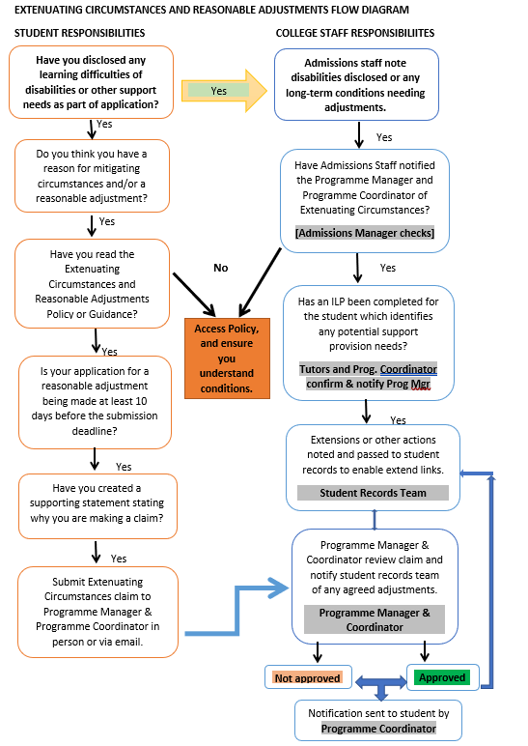

Supported Learning includes the resources, strategies, and practices that provide physical, social, emotional, and intellectual support intended to enable all students to have an equal opportunity for success by addressing barriers to and promoting engagement in learning and teaching.

