Health and Safety Policy

Purpose of policy
- CECOS College London (the Employer) takes health and safety issues seriously and is committed to protecting the health and safety of staff, students and all those attending our premises. This policy is intended to help the Employer achieve this by clarifying who is responsible for health and safety matters and what those responsibilities are.
- This is a statement of policy only and does not form part of any contract of employment. This policy may be amended at any time by the Employer at their absolute discretion.

Who is responsible for workplace health and safety?
- Achieving a healthy and safe workplace is a collective task shared between the Employer and staff. This policy and the rules contained in it apply to all staff of the Employer, irrespective of seniority, tenure and working hours, including all employees, directors and officers, consultants and contractors, casual or agency staff, trainees, homeworkers and fixed-term staff. Specific responsibilities of staff are set out in the section headed "Responsibilities of all staff" below.

Employer responsibilities
- The Employer is responsible for:
  - taking reasonable steps to safeguard the health and safety of staff and of people visiting our premises;
  - identifying health and safety risks and finding ways to manage or overcome them;
  - providing a safe and healthy place of work and safe entry and exit arrangements, including during an emergency situation;
  - providing and maintaining safe working areas, equipment and systems and, where necessary, appropriate protective clothing;
  - providing safe arrangements for the use, handling, storage and transport of articles and substances;
  - providing adequate information, instruction, training and supervision to enable all staff to do their work safely, to avoid hazards and to contribute positively to their own health and safety at work;
  - promoting effective communication and consultation between the Employer and staff concerning health and safety matters;
  - if an epidemic or pandemic alert is issued, providing instructions, arrangements and advice to staff as to the organisation of business operations and steps to be taken to minimise the risk of infection; and
  - regularly monitoring and reviewing the management of health and safety at work, making any necessary changes and bringing those to the attention of all staff, including those who may be working from home.
- The Director of Facilities and the Managing Director as the Lead Health & Safety contacts appoint centre managers on each site, as appropriate, to have overall responsibility for health and safety. The Managing Director and Director of Facilities will work with the Centre Managers to ensure appropriate procedures, information and training on health and safety matters is put in place for all employees.
- Any concerns about health and safety matters should be notified to the Managing Director or the Director of Facilities.
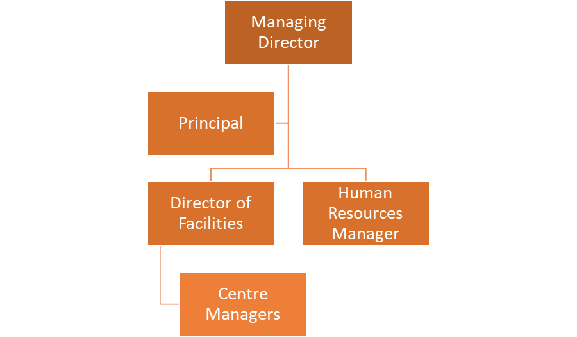
Figure 1: Health and Safety Management Responsibilities.

Responsibilities of all staff

General staff responsibilities
- All staff must:
  - take reasonable care for their own health and safety and that of others who may be affected by their acts or omissions, including when working from home;
  - co-operate with the lead Health and Safety Officers and the Employer generally to enable compliance with health and safety duties and requirements;
  - comply with any health and safety guidance, instructions, rules and responsibilities, including those linked to working from home;
  - keep health and safety issues in the front of their minds and take personal responsibility for the health and safety implications of their own acts omissions and environment;
  - keep the workplace tidy and hazard-free;
  - report all health and safety concerns to the lead Health and Safety Officers, including any potential risk, hazard or malfunction of equipment, however minor or trivial it may seem; and
  - co-operate in the Employer's investigation of any incident or accident which either has led to injury or which could have led to injury, in the Employer's opinion.

Staff responsibilities relating to equipment
- All staff must:
  - use equipment as directed by any instructions given by representatives of management or contained in any written operating manual or instructions for use and any relevant training;
  - report any fault with, damage to or concern about any equipment (including health and safety equipment) or its use to the Principal Health and Safety Officer;
  - ensure that health and safety equipment is not interfered with; and
  - not attempt to repair equipment unless suitably trained and authorised.

Staff responsibilities relating to accidents and first aid
- All staff must:
  - report any accident at work involving personal injury, however trivial, to the Principal Health and Safety Officer so that details can be recorded in the Accident Book and cooperate in any associated investigation;
  - familiarise themselves with the details of first aid facilities and trained first aiders, which are displayed on the notice boards in the College and available from the Principal Health and Safety Officer;
  - if an accident occurs, contact reception and ask for the duty first aider, giving name, location and brief details of the problem.

Staff responsibilities relating to national health alerts
- Where an epidemic or pandemic alert is issued, all staff must comply and co-operate with all instructions, arrangements and advice issued by the Employer as to the organisation of business operations and steps to be taken by staff to minimise the risk of infection. Any questions should be referred to the Principal Health and Safety Officer.

Staff responsibilities relating to emergency evacuation and fire
- All staff must:
  - familiarise themselves with the instructions about what to do if there is a fire which are available from lead Health and Safety Officers on each site;
  - ensure they are aware of the location of fire extinguishers, fire exits and alternative ways of leaving the building in an emergency;
  - comply with the instructions of fire wardens if there is a fire, suspected fire or fire alarm (or a practice drill for any of these scenarios);
  - co-operate in fire drills and take them seriously (ensuring that any visitors to the building do the same);
  - ensure that fire exits or fire notices or emergency exit signs are not obstructed or hidden at any time;
  - notify the lead Health and Safety Officers immediately of any circumstances (for example, impaired mobility) which might hinder or delay evacuation in a fire.
- On discovering a fire, all staff must:
  - immediately trigger the nearest fire alarm and, if time permits, call reception and notify the location of the fire; and
  - attempt to tackle the fire ONLY if they have been trained or otherwise feel competent to do so.
- On hearing the fire alarm, all staff must:
  - remain calm and immediately evacuate the building, walking quickly without running, following any instructions of the fire wardens;
  - leave without stopping to collect personal belongings;
  - stay out of the lifts; and
  - remain out of the building until notified by a fire warden that it is safe to re-enter.

Risk assessments, display screen equipment and manual handling
- Risk assessments are simply a careful examination of what in the workplace could cause harm to people. The Employer will carry out general workplace risk assessments when required or as reasonably requested by staff. Managers must ensure that any necessary risk assessments take place and the resulting recommendations are implemented.
- Staff who use a computer for prolonged periods of time may request a workstation assessment by contacting the lead Health and Safety Officers. Staff should be made aware of the Health and Safety Executive guidance on ‘Working with display screen equipment (DSE), both on site and when working from home.
- Work station guidance should include the following key elements as specified by the Health & Safety Executive (HSE) including:
  - Appropriate posture/position:
    - Forearms should be approximately horizontal and the user’s eyes should be the
same height as the top of the screen.
    - Make sure there is enough work space to accommodate all documents or
other equipment. A document holder may help avoid awkward neck and eye
movements.
    - Arrange the desk and screen to avoid glare, or bright reflections. This is often
easiest if the screen is not directly facing windows or bright lights.
    - Adjust curtains or blinds to prevent intrusive light.
    - Make sure there is space under the desk to move legs.
    - Avoid excess pressure from the edge of seats on the backs of legs and knees.
A footrest may be helpful, particularly for smaller users.
- Well-designed workstations
Keyboards and keying in (typing):
- A space in front of the keyboard can help you rest your hands and wrists when
not keying.
- Try to keep wrists straight when keying.
- Good keyboard technique is important – you can do this by keeping a soft touch on the keys and not overstretching the fingers.
Using a mouse
- Position the mouse within easy reach, so it can be used with a straight wrist.
- Sit upright and close to the desk to reduce working with the mouse arm stretched.
- Move the keyboard out of the way if it is not being used.
- Support the forearm on the desk, and don’t grip the mouse too tightly.
- Rest fingers lightly on the buttons and do not press them hard.
- Guidance on moving and handling (for example, lifting and carrying heavy objects) can be obtained from the nominate site manager or the lead Health and Safety Officers.

Non-compliance with health and safety rules
- Any breach of health and safety rules or failure to comply with this policy will be taken very seriously and is likely to result in disciplinary action against the offender, up to and including immediate dismissal.
Accident Reporting
- All accidents, incidents or near misses must be reported. To provide transparency the following definitions are provided:
- Accident: an event that results in injury or ill health
- Incident: all other events or dangerous occurrence that takes place that do not cause injury or ill health to a person (including fire, building/structural collapse or disturbance of asbestos).
- Near Miss: an event not causing harm, but has the potential to cause injury or ill health
- Accident reporting is covered by the Reporting of Injuries, Diseases and Dangerous Occurrences Regulations 2013 (RIDDOR). The College aim to reduce accidents to a minimum, and will carry out detailed analysis of the number and type of accidents, and near misses occurring within the College’s area of responsibility to ensure trends are identified and remedial steps are put in place to prevent reoccurrence.
- All accidents, incidents and near misses will be investigated in line with procedures to prevent recurrence. Where an accident, incident or near miss requires reporting to the Health and Safety Executive (HSE) under RIDDOR, this report must only be submitted by the Health & Safety Advisor or Director of IT & Estates.
Job Title | Signature | Date
Managing Director |  | 5 September 2024
Director of Facilities

