Internal and External Verification Policy

Introduction

Internal verification is used for those programmes where there is a need to provide students with a series of assessment opportunities which have been primarily designed by the individual lecturer or the course team, or are first marked and verified by the course team. Assessments must meet the predetermined module and qualification assessment criteria set by the Awarding Bodies and organisations.

Students are normally taught in groups and the teaching follows a Scheme of Work. The planned teaching must cover all the key learning outcomes as set out in the module/unit descriptor and/or handbook. All assessments much be checked and approved by the Lead Internal Verifier or partner university module leader for the subject area before being given to students. Programme Managers support the system by ensuring that timelines are adhered to. This forms part of the broader academic standards management and quality assurance of CECOS College London.

UK Quality Code for Higher Education advice and guidance
Themes: Assessment

Aims and Objectives

Internal Verification (IV) and External Verification (EV) including External Quality Assurance (EQA) is the process of monitoring assessment practice in order to ensure that assessment decisions meet national standards. It provides a continuous check on the consistency, quality and fairness of marking, grading and overall assessment of student’s work. The process will ensure:

- all students are fairly, accurately and regularly assessed in a consistent manner and that assessment strategies are inclusive and meet the learning outcomes

- exceed the requirements placed upon CECOS by QAA, the Regulated Qualifications Framework (RQF), regulatory authorities, the awarding bodies, partner universities, and the student charter

- ensure that valid assessment decisions are reached for all students and that external requirements are fully met

- support academic staff in their assessment activities by affording them the opportunity to receive critically supportive comment on the assessment decisions reached

- ensure that all students/learner work is subject to internal verification during their programme.

- module/unit completion can only be signed off once all assessment elements have been successfully completed, including practical elements. All module/unit components must be consistently assessed and appropriately internally verified to support the assessment decisions and appropriate feedback provided.

Defined responsibilities

Internal verification is a process which ensures that all assessment and grading is consistent across modules within a programme, is fit for purpose and that assessment decisions are explicitly made against grading criteria and learning outcomes. In most cases the Programme Manager will be the Lead Internal Verifier and other team members will also undertake internal verification and moderation of work to support standardisation.

The management of Internal Verification will include support for new assessors and internal verifiers. Where a new member of staff joins the team, the Programme Manager will ensure that all assessment briefs set are internally verified, and in the first term all marking undertaken is moderated or second marked. In the remaining two terms of the first year of teaching with CECOS, assessment decisions will be sampled and feedback scrutinised on the basis of 50% of work marked in term 2, and 25% in term three provided the standard of marking is appropriate, and the quality of feedback meets expectations. The table below provides a summary of the sampling of assessed work,

 | Main Submission |  | Resubmitted work
Assessor experience | Percentage sampled | Minimum number of students (if less than 100% sample) | Percentage sampled | Minimum number of student (if less than 100% sample)
More than 5 years teaching & assessing | 10 | 10 | 10 | 5
Less than 5 years teaching & assessing | 20 | 15 | 20 | 10
No previous experience or new to teaching | 50 | 25 | 50 | 15

Where new Internal Verifiers are appointed, their work will be moderated by a Lead Internal Verifier from the same subject area, or from another subject area, as appropriate, for the first term. The quality of feedback will be a key feature of moderation along with comments in support of standards.

Resource allocation.

The internal verification role is recognised as part of the Programme Manager role and the course administration time. Where teaching staff undertake internal verification of work, they may claim for additional payments, as appropriate. Course administrators support this process by recording internal verification or tracking this on-line.

In the case of new assessors and internal verifiers, the Head of Higher Education or a senior manager for Further Education will be expected to ensure that for the first term all assessed work is second marked, to ensure the fairness and appropriateness of grading decisions. In the case of small groups (up to 12 students) all work will be second marked for the first year.

New internal verifiers will be similarly expected to have their worked checked and they will be mentored by an experienced College IV, normally drawn from within the same subject grouping. Shadowing and support will be for the first year also.

Operational description and scope.

To ensure the academic standards and the fairness and transparency of assessment, all
assessment briefs must be internally verified, and signed off, to include acknowledgement of
recommended changes, before being released to students, unless set by the awarding body
or by the partner university.

A sample of assessed work must be internally verified, including:
- Where there are fewer than 5 students, all scripts must be internally verified.
- In groups of up to 12 students, 50% of scripts must be internally verified.
- For larger groups at least 7 or 8 scripts should be internally verified to a minimum of 10 – 15% across the range of graded outcomes.
- In all cases, where students have failed or been referred, grading should be verified.
- The internal verification sample should include scripts from across the marking spectrum.
- Sampling must be across all assessors, types of evidence, all students (every student’s work must be IV’d at least once). For the practice-based elements of programmes, all practice elements must be assessed and internally verified to meet awarding body requirements.

Appropriately qualified staff must carry out all internal verification. Where trainee internal verifier undertakes IV, this must be verified by a qualified IV and countersigned.

IV of assessments must be carried out y throughout the year. In addition to this, each programme will identify appropriate periods of time when IV takes place and the courses team notified. Evidence produced must meet the requirements of the awarding bodies and the CECOS Quality Assurance Policy and as set out in the Quality Assurance Handbook.

The evidence must be recorded on appropriate documentation, which takes into account the requirements of awarding bodies and the CECOS Quality Assurance System.

Internal verification must take place before assessment decisions are finalised and notified to Assessment Board which will in turn be subject to external verification prior to notification and certification requests. Evidence should be available to the Programme Coordinator, Lead Verifier, Programme Manager, Director of Quality and the Principal. Records must be kept in a secure location and treated as confidential information in compliance with General Data Protection Regulations (GDPR) and the Data Protection Act 2018.

Internal verifiers must attend standardisation meetings and maintain a current continuous professional development file.

Standards Verification, Moderation and External Quality Assurance

External verification is undertaken by the relevant awarding organisation for each cohort.
The College submits internally verified assignments to external examiners /moderators /EQAs; this is in line with the requirements of the awarding organisation. The awarding body external verifiers also monitor the consistency and validity of the College’s assessment and internal verification processes. External Examiners and EQAs are given access to all pertinent documentation for assessment, as well as the opportunity to discuss with individual students and academic staff and to review any associated policies and procedures.

Monitoring and review

This policy will be monitored by the Director of Quality and the Quality Management Group, and through established quality audit procedures.

Related Policies
- Academic Appeals Procedure
- Assessment Policy
- Teaching and Learning Policy

Annex A: Internal Verification Flow Chart

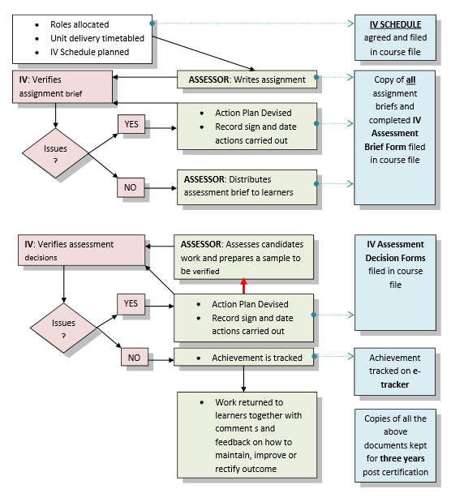
N.B. It may be necessary for students to submit additional work to meet the learning outcomes. This re-submission wok will also need to be sampled by the internal verifier.

